Breakfast Club Menu
2019-2020
8.00 am – 8.30 am
- Pancake- Muffin- Toast 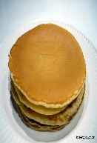
Topped with Flora spread, Jam, Honey

- Cereal Choice of 3
Rice Crispies /Malted Wheat/ Cornflakes/ Weetabix/Cheerio’s / Cornflakes

- Fruit.
Apples / Oranges / Pears / Banana

- Drinks.
- Apple Juice/Orange Juice /Milk /Water

- Yoghurts.
Strawberry or Fudge.

£1.00 per person per day.

Please let Miss Mc Nulty or Mrs Scullion know if you have any special dietary requirements.

