Halloween Theme Day
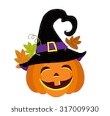
Thursday 24th October 2019 Menu:

Witches’ Fingers (Sausages)
Creepy Claws (Chips) 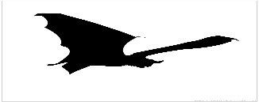
Blood Drops (Baked Beans)
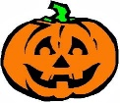Spooky (Artic Roll)
Trick or Treat Jelly 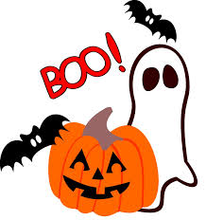
Not Suitable for the Teachers.

