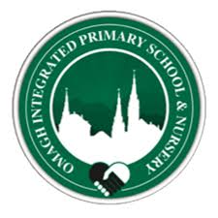

Term 3 Curriculum Update
April-June 2026
Year 4
Kind Hearts, Open Minds, Bright Futures.
Topics | - World War 2  - Current Events- World Cup 2026
Literacy | This term in Literacy we will be focusing on all key areas of the Literacy curriculum.  Children will enjoy a range of books during ERIC (Everyone Reading in Class) time and complete comprehension activities designed to build fluency, understanding, and reading strategies. We will continue to follow the Jolly Phonics/Grammar programme, revising and learning a wide range of sounds.  Our Complete Word Spelling Programme will continue, with weekly spellings and related class activities to reinforce learning.  In Grammar, we will be focusing on commas, prepositions, a or an, homophones, speech marks, exclamation marks, alphabetical order and paragraphs.  In Creative Writing, we will be looking at fact files and diary writing.  We will also maintain a strong emphasis on developing neat, consistent handwriting.
Numeracy | Through Numeracy we will be focusing on the following topics:  Number  · Numbers to 1000 – estimating, rounding and working with larger values.  · Money – recognising £5, £10 and £20 notes and calculating change from higher amounts.  · Addition – doubles and near doubles, including bridging strategies.  · Subtraction from numbers to 1000.  · Multiplication – x2, x3, x4, x5 and x10.  · Division by 2, 3, 4, 5 and 10.  Capacity  · Exploring the half litre and millilitres.  2D Shape  · Symmetry and identifying symmetrical objects.  Time  · Revising o’clock, quarter past, half past and quarter to.  · Reading times in 5 minute intervals.  · Calculating durations and solving time-related word problems.  Data Handling  · Carroll diagrams.
WAU | World War 2  Through our World War 2 topic, pupils will explore the major countries involved in the conflict and learn how the war affected Northern Ireland, especially during the Belfast Blitz. They will investigate what life was like for evacuee children, how people travelled during the war and how communities adapted to rationing and shortages. Pupils will also design and build their own Anderson shelters, learn about the changing roles of women and children and discover how people reused and repaired items through “Make Do and Mend.” Finally, they will learn about Anne Frank’s life in hiding and discuss themes of resilience and rebuilding.  Current Events/ World Cup  Through our World Cup 2026 topic, pupils will explore different countries around the world and learn to recognise their flags. They will find out where these countries are on a map, discover key facts about them and compare their cultures. Using the excitement of the World Cup, pupils will also learn about teamwork, fair play and global celebrations. This topic helps them understand how sporting events bring countries together and highlights the diversity of our world.
ICT | This term in UICT, pupils will be exploring Exploring Data. Year 4 will collect data and insert it into a table on Microsoft Word. In the second half‑term, our focus will move to Digital Art and Design.  Year 4 will use a paint package to paint a picture using ICT. They will also add a title and graphic/ stamp to their picture. They will print and save a copy of their work.
PDMU | This term in PDMU, we will be exploring a variety of different themes.  We will link this topic with our World Around Us activities and look at the feelings and emotions of evacuees during WW2.  We will also learn how to look after ourselves during the hot weather/ Summer season.
P.E | Our PE Day this term is on a Tuesday.
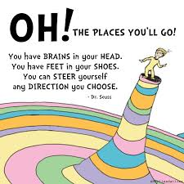
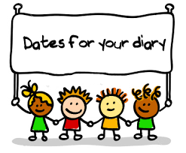
Calendar Events are highlighted in Bold.

