**Nursery & Y1 Admissions for September 2017**

We held a successful Open Day on Friday 25th November and thanks to everyone who attended and took the time to view our school!

There are many good schools in the Omagh area who are all trying to attract new pupils for 2017/18 enrolment. Parents will currently be considering which school to send their children to and…

**WE’D LIKE THEM TO CHOOSE OIPS & Nursery!**

Word of mouth is generally the best advertising we can get so **we are asking you, as parents, to help promote OIPS & Nursery amongst your friends, family, neighbours and colleagues** and tell them about the virtues of our school.Direct them to our school website… [www.omaghintegratedps.com](http://www.omaghintegratedps.com)

Or ask them to contact the school directly for further information or to arrange a visit.  **If you have a Nursery or Year One application to make, please remember the deadline – noon on 11th January 2017.** Applications received after this date will be marked as late and may result in your place being given to another applicant!

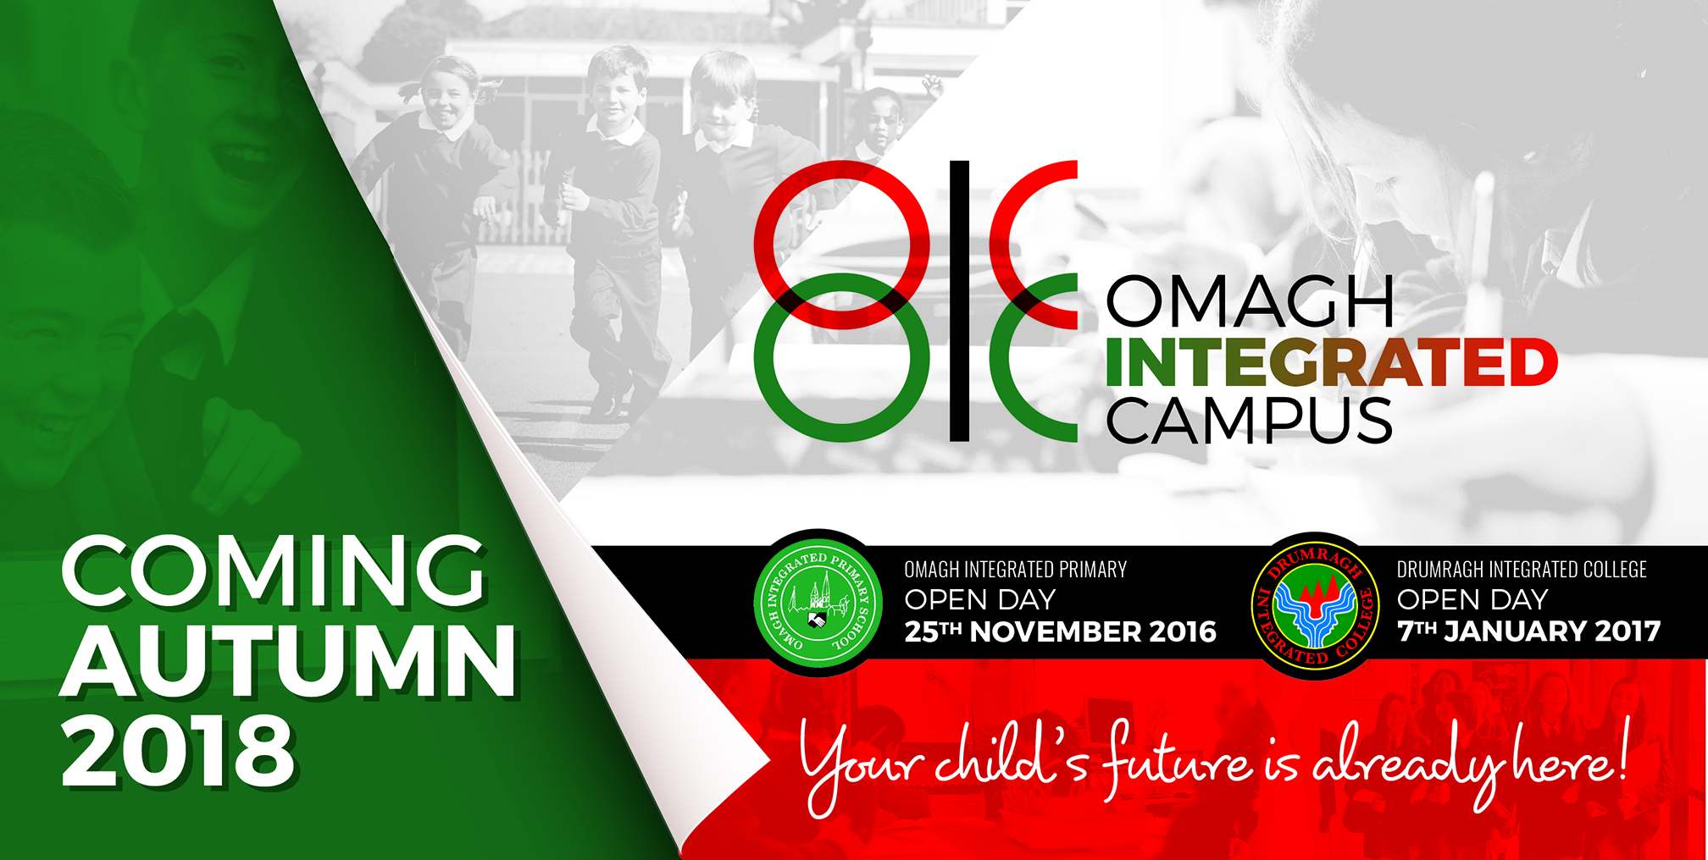

**You may have seen the recent billboard advertisements at James Street announcing the launch of the exciting new OMAGH INTEGRATED CAMPUS project. OIC will be formed upon the completion of our new school to be located beside Drumragh Integrated College and offers parents the opportunity to have their children educated *‘from toddler to teen’* in a truly INTEGRATED setting ensuring a seamless continuity between primary and secondary integrated education. As the strapline in the ad says*… ”Your child’s future is already here”.* Further details to follow!**

[](http://www.bing.com/images/search?q=christmas+dinner+pictures+clip+art&id=7C2FEDCCB15CCB033AD1D12B3BCBABFC5A770DD8&FORM=IQFRBA) CHRISTMAS DINNER

Christmas Dinner will be served next week and the arrangements are as follows:

Tuesday 13th - KS1 pupils.

Wednesday 14th -KS2 pupils.

**NEW SCHOOL ANNOUNCEMENT!**

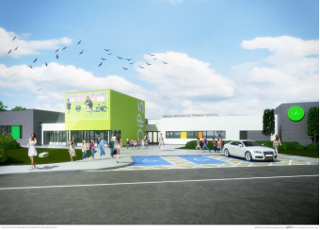

**The Board of Governors are delighted to inform you that local contractors, Woodvale Construction, have been  awarded the contract to build our new school** *(subject to  a 10-day ‘standstill’ period ending on 16th December)***. This is fantastic news for the whole OIPS community and will ensure a late December/Early January start for ground works and construction to begin. We’re another step closer to fulfilling the dreams and aspirations of those insightful founders who started it all off twenty six years ago and look forward with confidence and enthusiasm to our ‘state-of -the -art’ new building.**

**YEAR 5 MUSEUM TRIP**

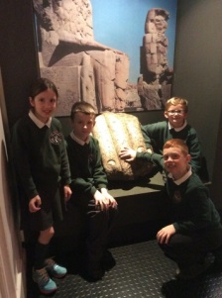The Year 5 classes visited the Ulster Museum in Belfast on Thursday 17th November. They got the chance to learn about life and death in Ancient Egypt and to handle and observe authentic artefacts. Impeccable manners were in evidence throughout! Well done, Year 5’s. We are very proud of you all and a big THANK-YOU to the staff for arranging the trip and parent volunteers who helped out on the day.

Y6 VIKING DAY

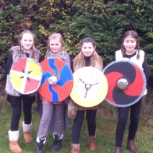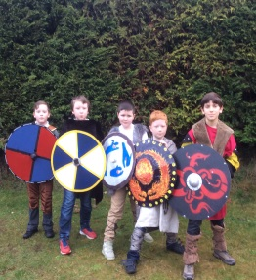

Y6’s thoroughly enjoyed dressing up for their VIKING DAY in school on Friday 2nd December when they lived-out the ‘Viking Experience’ right here in OIPS …**PLENTY OF VICIOUS VIKINGS ABOUT THAT DAY!** Well done to Mrs Clements, Miss Finlay and Mrs McBride for getting into the spirit of the day by dressing up accordingly.

***Child Protection.***

Staff at OIPS are always ready to listen to any problems or queries you may have. Sometimes you may have other concerns where you or your children may want to talk in confidence to an appropriate adult. Our Designated Child Protection Teacher is Mrs McKernan, Year 3 and Deputy Child Protection Teacher is Mrs Taggart, Year 7.

**PARENTS’ COUNCIL NEWS**

[](http://www.google.co.uk/url?sa=i&rct=j&q=&esrc=s&source=images&cd=&cad=rja&uact=8&ved=0ahUKEwjMoLrJv93QAhWLAcAKHWNKB-cQjRwIBw&url=http://happymerrychristmas.net/christmas-images-2016-facebook-whatsapp/&bvm=bv.139782543,d.ZGg&psig=AFQjCNEQc-zG9ugP615qDOFuMc7_AH--1w&ust=1481042535490833)**The Parents’ Council want to thank all parents for supporting their activities during the first term and look forward to the new term when a full programme of fun activities and events are planned. We would like to invite new and existing members to our first meeting of 2017 at 7.00pm on TUESDAY 10th JANUARY in the staff room.**

**DECEMBER DATES**

[](http://www.google.co.uk/url?sa=i&rct=j&q=&esrc=s&source=images&cd=&cad=rja&uact=8&ved=0ahUKEwiSieKbvt3QAhUXOsAKHaAwCBcQjRwIBw&url=http://www.happy-newyearimages.com/new-year-gallery/&bvm=bv.139782543,d.ZGg&psig=AFQjCNHAszGPPWiPm__Dps6JOwDbRZBXLQ&ust=1481042180004279)[](http://www.bing.com/images/search?q=nativity+pictures+clip+art&id=1FBB3BE8C7E549F87EBCA27EE8D0973ACBBC97B7&FORM=IQFRBA)**Fri. 2nd** – 6.00pm to 9.00pm Craft Fair . Fundraiser for Friends Playgroup and Afterschool

**Mon. 5th** - Y2’s - IFA/GAA joint Fun Day

**Wed. 7th** Y1 Nativity for parents.

Q101 Recording of Senior Choir

**Thurs. 8th** Year 2 Nativity for parents.

**Fri. 9th** KS2 Choir performing at OMAGH CHURCHES FORUM Christmas Carol Service outside Danske Bank Omagh – 1.00pm -1.30pm.

**Mon. 12th** . KS1 & 2 Carol Service in the hall @ 10am

**Tue. 13th** KS1 Christmas Dinner

**Wed. 14th** KS2 Christmas Dinner –

Senior Choir Performance at First Omagh Church, Dublin Road.

**Fri. 16th** (1) Nursery Christmas Show – 10.30am (2) Choir of the Year recording @11am

**Tues. 20th** NO NURSERY & ½ day for the end of term…

**Y1-Y3 & siblings to be collected at 12noon.**

**Y4-Y7 to be collected at 12.30pm.**

(Please note that no dinners will be served on Tuesday 20th)

**SCHOOL RE-OPENS ON WEDNESDAY 4th JANUARY 2017**

**Have a very Merry Christmas and a Happy New Year – from all at OIPS!**

**Christmas Cards, designed by the children in OIPS Friends After School Club are available for £5 per pack from Mrs Fowler.**